***QUESTION#1***

Draw the flowchart to withdrawal cash from ATM.

***QUESTION#2***

Write an algorithm of the following flowchart.

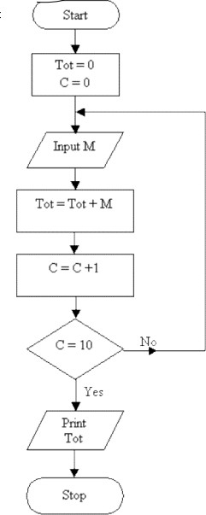

***QUESTION#3***

An admission charge for The Little Rep Theater varies according to the age of the person. Draw a flowchart to print the ticket charge given the age of the person. The charges are as follows:

* + 1. *Over 55: PKR 10.00*
    2. *21–54: PKR 15.00*
    3. *13–20: PKR 10.00*
    4. *3–12: PKR 5.00*
    5. *Under 3: Free.*

*.*

***QUESTION#4***

Write an algorithm to check whether a given number is prime or not.



***QUESTION#5***

Write a program to evaluate the area and perimeter of rectangle. Ask user to supply length and breadth separately on the same line replacing the previous statement. Output screen should only print the answer in a comprehensive way e.g.

*The area and perimeter of rectangle with length = ______ and breadth = ______ are respectively ______ and ______ units.*

*Area = wl*

*Perimeter = 2(l+w)*

***QUESTION#6***

Write a program to print hollow diamond star pattern using escape sequences.

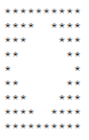

***QUESTION#7***

A sweater is on sale for 25% off the original price. The original price is $50. Write

a solution to calculate and print the sale price.

***QUESTION#8***

Write a program which takes a character as an input and display corresponding ASCII code.